

Version: v1.0

Author: Sridhar Kannan

TFL – Solution Deployment and Configuration Steps

Created date: 17/09/2023

Contents

1. Introduction 2

1.1 Purpose of the document 2

2. Prerequisites 2

2.1 System Requirements 2

2.2 Pre-Deployment Checklist 3

3. Deployment Step 3

4. Post-Import Configurations 4

4.1 User Roles and Permissions 4

4.2 Business Unit, Teams, User Roles, and Permissions 6

1. Introduction
   1. Purpose of the document

This document serves as a comprehensive guide for deploying and configuring a custom solution for the development scenario.

1. Prerequisites
   1. System Requirements

The system should contain Dynamics 365 Customer service enabled in it.

* 1. Pre-Deployment Checklist
* Create a team “Parent Confidential” at parent BU level and include only admin user to the team and assign ‘Confidential case team’ role.

1. Deployment Step

Import the solution package “ContactCentreandOperation_1_0_0_1_managed.zip” into the Power App solution.

The solution will be imported with a warning message, which will be addressed in the post-deployment steps.



1. Post-Import Configurations
   1. User Roles and Permissions

* Create a team “Parent Confidential” at parent BU level and include only admin user to the team and assign ‘Confidential case team’ role to the team.

* To Resolve the warning occurred during solution import, Open the solution, and navigate to process and edit the workflow ‘Escalation Email to the Team’ to update the custom workflow properties.

* Select the newly created Team ‘Parent Confidential’ in the parent confidential lookup field.

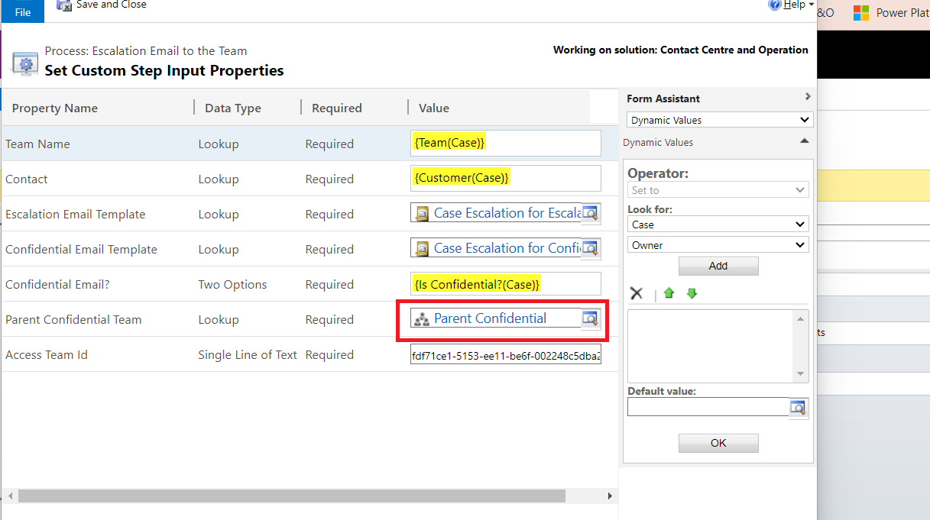

* Save and activate the process.
  1. Business Unit, Teams, User Roles, and Permissions

**Business Unit**

Based on requirements create three Business Unit (Contact centre)

* Underground
* Overground
* Buses

**Team**

Create the following teams for all the above BU and add the appropriate members to the team.

* Confidential Case Team
  + Confidential Case Team – Underground
  + Confidential Case Team – Overground
  + Confidential Case Team – Buses
* Escalation Team
  + Escalation Team – Underground
  + Escalation Team – Overground
  + Escalation Team – Buses

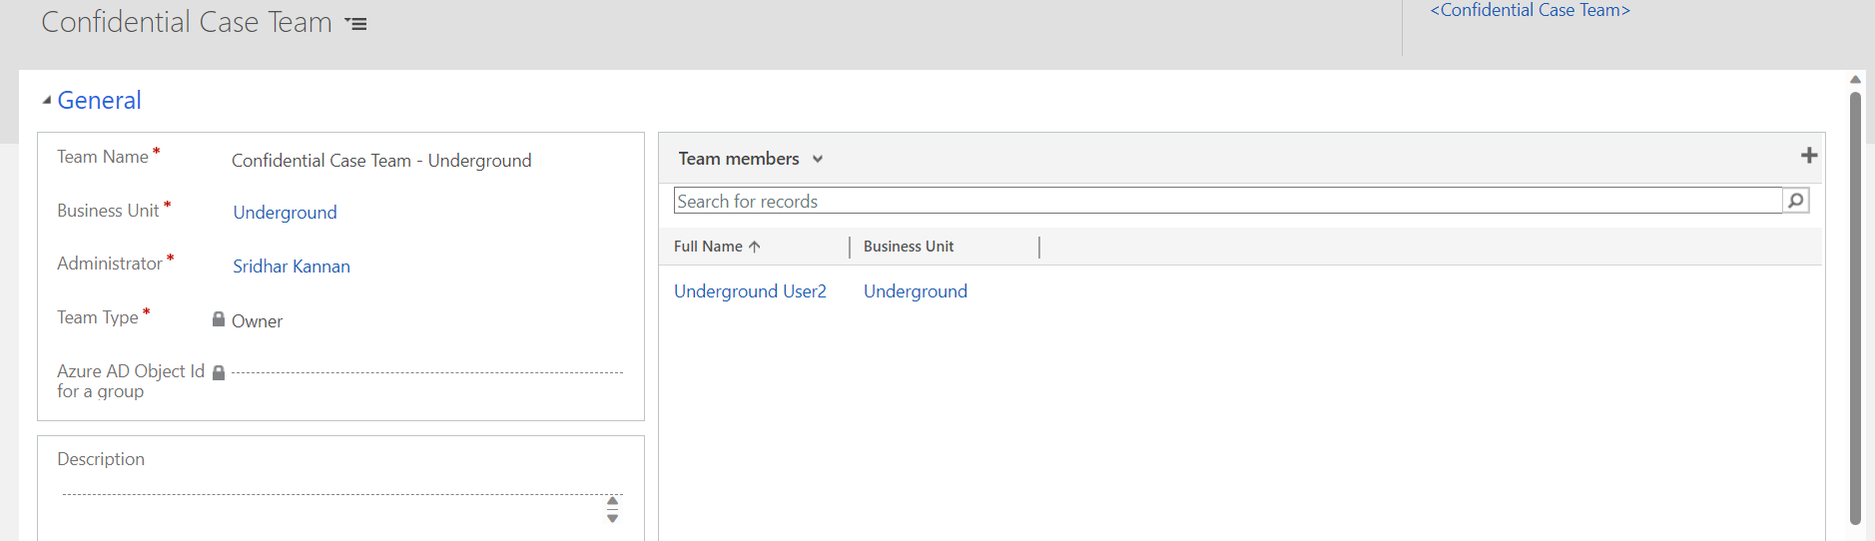

**User Role**

* Customer Service Agent – Assign this role to customer service agent users.
* Customer Service Manager – Assign this role to the Managers.
* Escalation Team – Assign this role to “Escalation team” created above.
* Confidential Case Team - Assign this role to “Confidential Case Team” created above.

**Queues**

Open the private queue that has been created against the team (confidential case team and escalation team) and provide email (group email) to the queue, so the users of the team will receive the follow-up email.

